|  |  |  |  |  |  |
| --- | --- | --- | --- | --- | --- |
| Date | 30-Nov-22 | | | Tester Name | Andrew McLaughlin |
| Environment | Penfax - Test | | | Login used |  |
| Operating System | Select OS | Version: | Update: | | |
| Software Used | Select Software | Version: | Update: | | |
| Select Software | Version: | Update: | | |
| Release version | 22.4.1 | | | | |
| Title | Calculates proper guarantee period end date | | | | |
| Test Type | Regression | | | | |
| Test Scenario | Calculates proper guarantee period end date | | | | |
|  |  | | | | |
| Expected Results |  | | | | |
| Pass/Fail | Pass | | | JIRA# | N/A |

Describe your steps with screenshots:

Verify the member has a guarantee period in their pension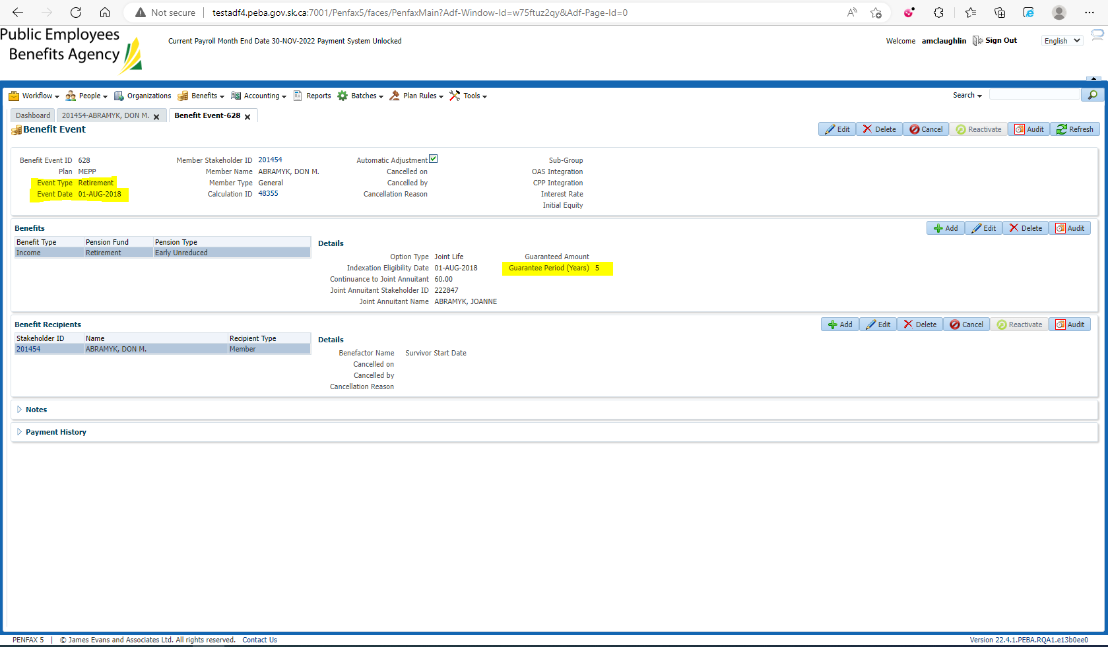

Add their Date of Death under Person Profile > Edit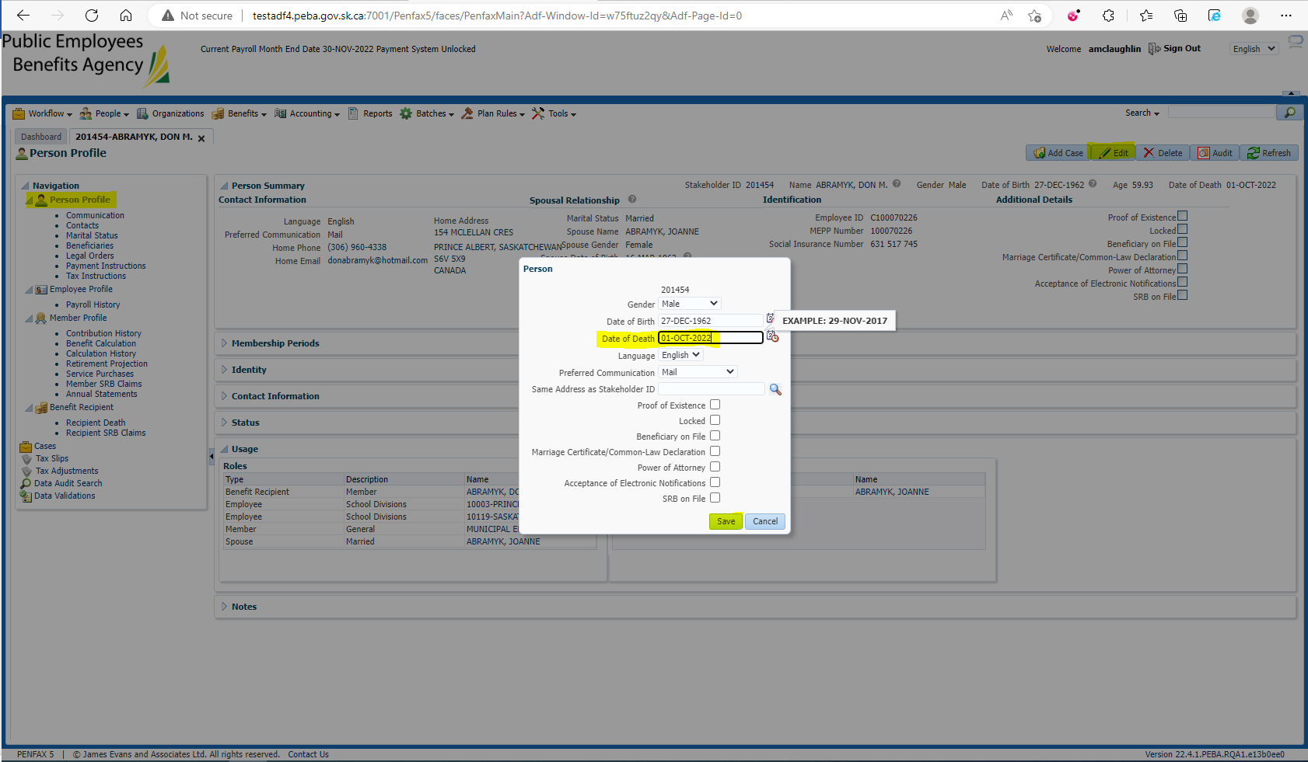

Add the Spouse to the Benefit Recipient with a start date on the 1st after the month the member passed away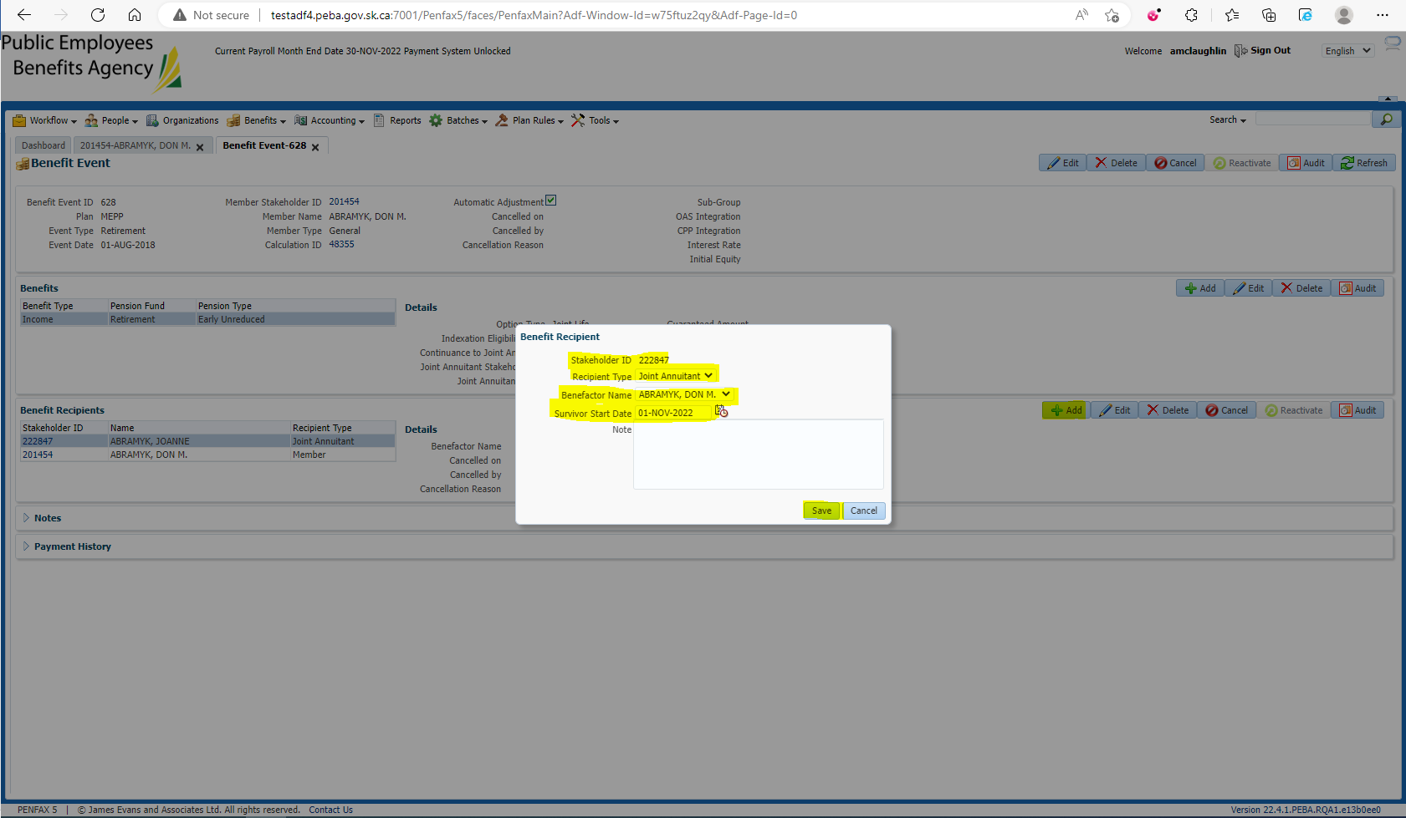

Run the Death Calc, Process x2, Process Recipients x2. Check the GP expiry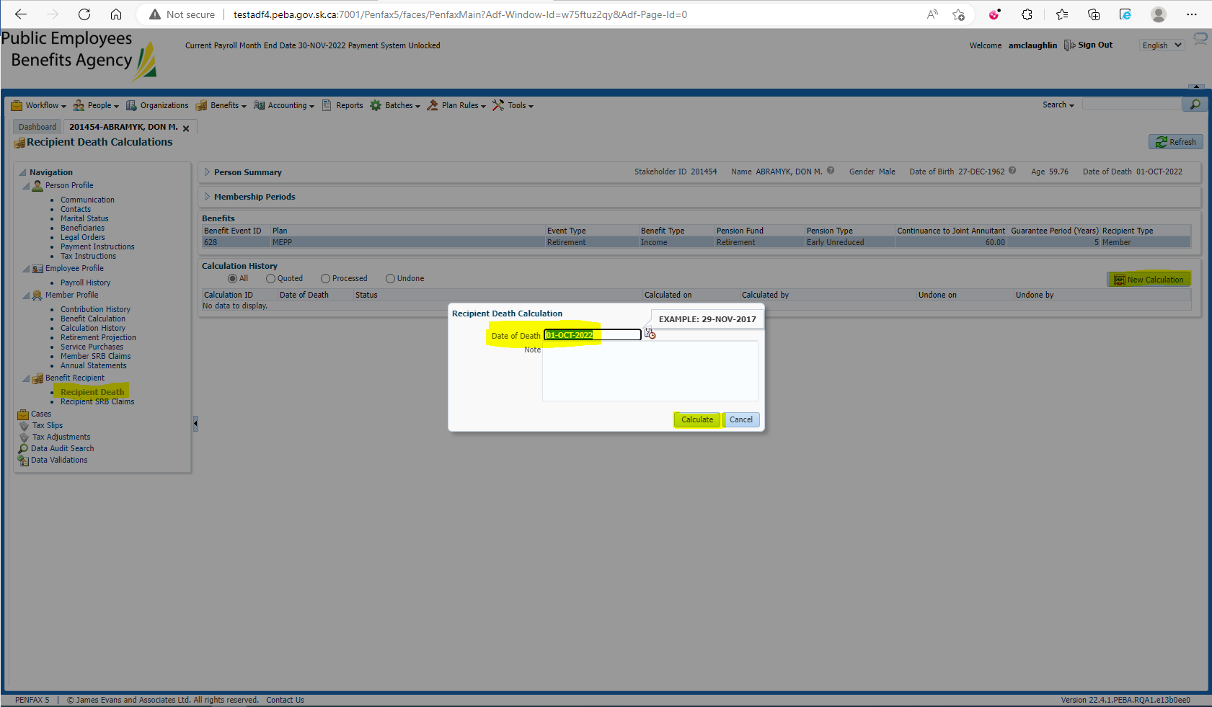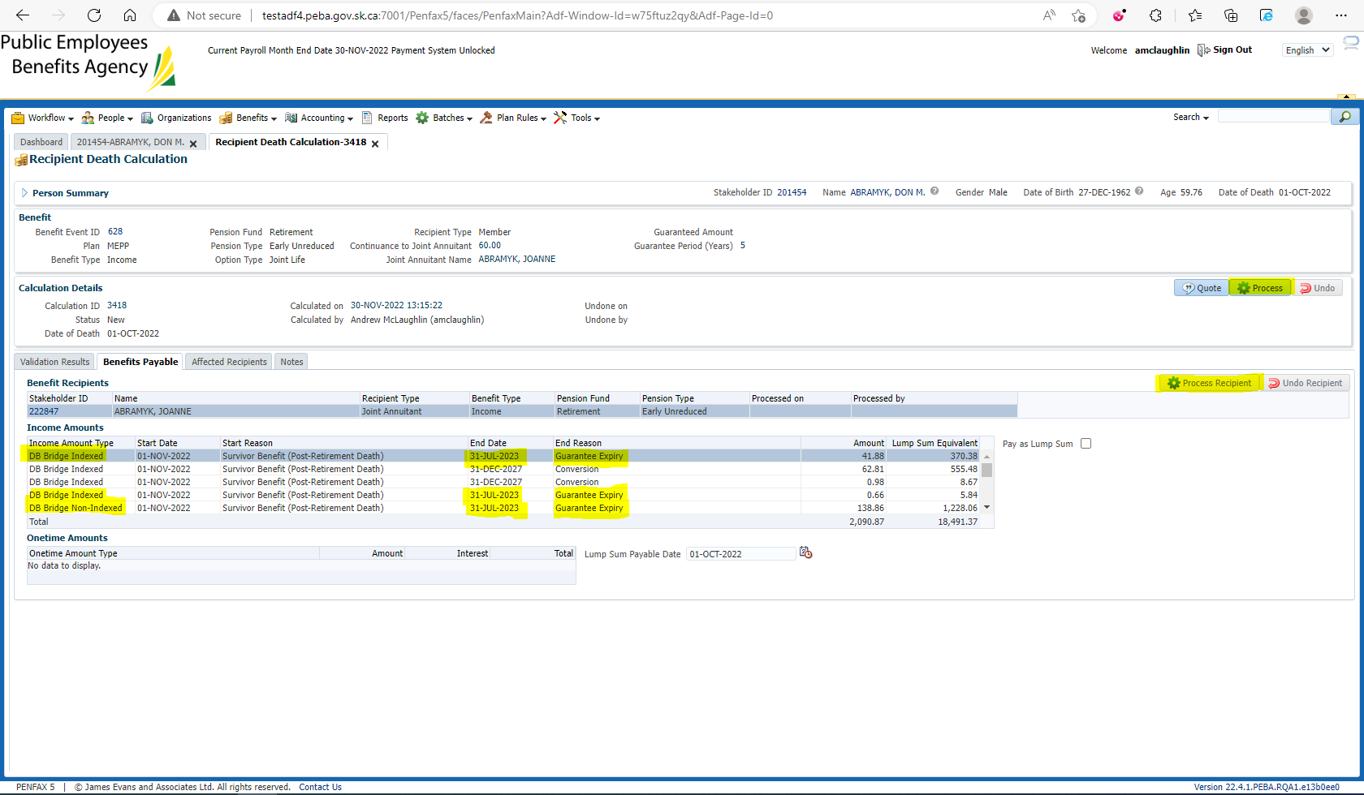

Compare guarantee expiry to retirement date: 

August 2018 + 5 years = July 2023